# ROUTER

**Router:** enable

**Router:** Configure terminal

**Router:** Ip dhcp excluded-address 192.168.77.0 192.168.77.10

**Router:** Ip dhcp pool VLAN30

**Router:** Network 192.168.77.0 255.255.255.0

**Router:** Default-router 192.168.77.1

**Router:** Dns-server 192.168.76.98

**Router:** exit

**Router:** Ip dhcp excluded-address 192.168.78.0 192.168.78.10

**Router:** Ip dhcp pool VLAN40

**Router:** Network 192.168.78.0 255.255.255.0

**Router:** Default-router 192.168.78.1

**Router:** Dns-server 192.168.76.98

**Router:** exit

**Router:** int g0/0/1.20

**Router:** encapsulation dot1q 20

**Router:** ip address 192.168.76.1 255.255.255.0

**Router:** exit

**Router:** int g0/0/1.30

**Router:** encapsulation dot1q 30

**Router:** ip address 192.168.77.1 255.255.255.0

**Router:** exit

**Router**: ip access-list extended NO-Access-Intern-VLAN40

**Router:** Permit tcp any any eq domain

**Router:** Deny tcp 192.168.78.0 0.0.0.255 192.168.76.0 0.0.0.255

**Router:** Deny tcp 192.168.78.0 0.0.0.255 192.168.77.0 0.0.0.255

**Router:** Permit tcp any any

**Router**: Exit

**Router:** int g0/0/1.40

**Router:** encapsulation dot1q 40

**Router:** ip address 192.168.78.1 255.255.255.0

**Router**: ip access-group NO-Access-Intern-VLAN40 out

**Router:** exit

**Router:** int g0/0/1.50

**Router:** encapsulation dot1q 50

**Router:** ip address 192.168.79.1 255.255.255.0

**Router:** exit

**Router:** int g0/0/0

**Router:** no shutdown

**Router:** Int se0/1/0

**Router:** No shutdown

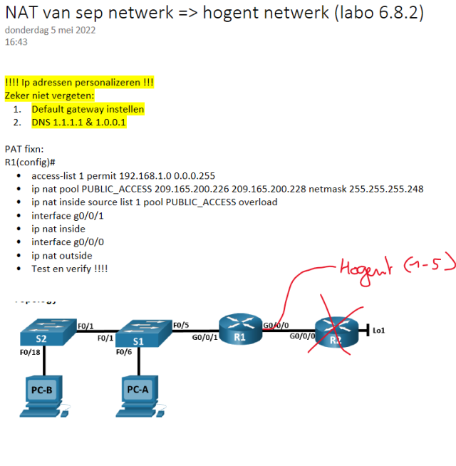

**Router:** Access-list 1 permit 192.168.0.0 0.0.255.255

# Switch1

**Switch:** enable

**Switch:** configure terminal

**Switch:** hostname S1

**S1:** vlan 20

**S1:** Name Servers

**S1:** vlan 30

**S1:** Name werkstations

**S1:** vlan 40

**S1:** Name gastnetwerk

**S1:** vlan 50

**S1:** Name buiten

**S1:** exit

**S1:** Int range fa0/1-5

**S1:** Switchport mode access

**S1:** Switchport access vlan 20

**S1:** exit

**S1:** Int g0/1

**S1:** Switchport mode trunk

**S1:** exit

**S1:** Int g0/2

**S1:** Switchport mode trunk

**S1:** exit

**S1:** Int range g0/1-2

**S1:** Switchport trunk native vlan 50

# Switch2

**Switch:** enable

**Switch:** configure terminal

**Switch:** hostname S2

**S2:** int g0/1

**S2:** Switchport mode trunk

**S2:** vlan 20

**S2:** Name servers

**S2:** vlan 30

**S2:** Name werkstations

**S2:** vlan 40

**S2:** Name gastnetwerk

**S2:** vlan 50

**S2:** Name buiten

**S2:** exit

**S2:** Int range fa0/1-5

**S2:** Switchport mode access

**S2:** Switchport access vlan 30

**S2:** exit

**S2:** Int range fa0/6-10

**S2:** Switchport mode access

**S2:** Switchport access vlan 40

**S2:** exit

**S2:** int g0/1

**S2:** Switchport mode trunk native vlan 50